**Wall of Hearts Located Outside**

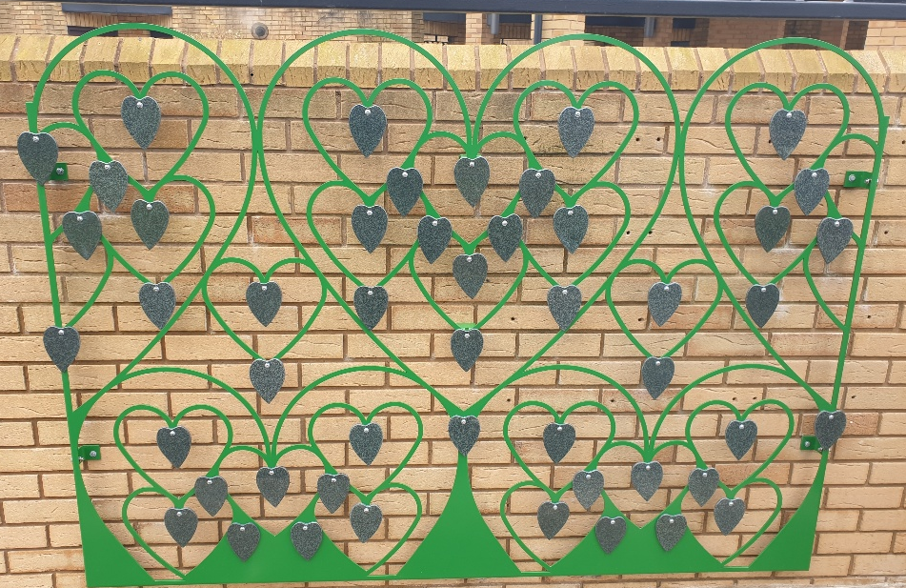

**Price**

5 Year Lease - £182.00

Motif - £31.00

5 Year Renewal - £101.00

Replacement Leaf – £75.00

**Prices are from**

**1st April 2023 to 31st March 2024**

The hand made granite heart plaques can be sand-blasted with a basic inscription and a motif of your choice.

**Plaques**

The lease options include a hand-made leaf with gilded letters, for an additional cost the following motif options are available:

* Heart.
* White Dove.
* White Feather.
* Red Robin.
* Bumblebee

* Butterfly.
* Ladybirds.
* Four Leaf Clover.
* Acorn.
* Cross.

.

Please contact the Bereavement Services Office at the time of ordering should you wish to see examples of the motifs available.

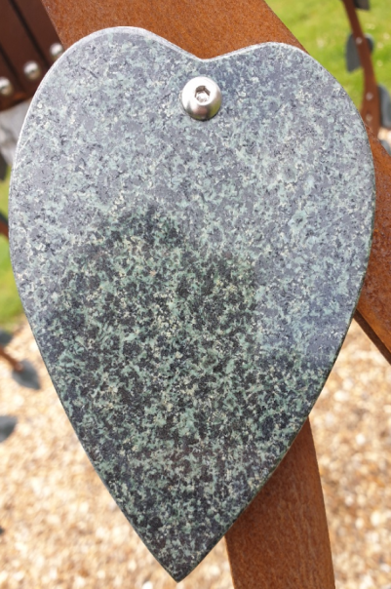**Heart Plaque Examples**

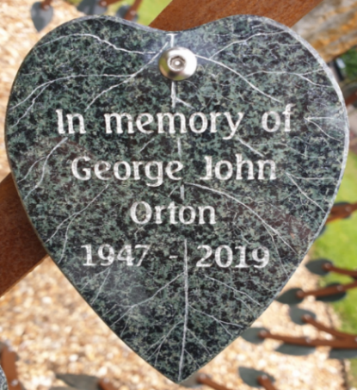



**PLEASE READ SIGN AND DATE THE CONDITIONS OF LEASE**

**CONDITIONS OF LEASE AGREEMENT WALL OF HEARTS**

The licensing of a memorial relates only to the provision and placement of a plaque. Any item, such as a memorial tree upon which the plaque is placed, is provided by and remains the property of the crematorium and is not included within the lease agreement. No ownership of that item is inferred to, or may be assumed by, the lease holder.

In order that the grounds are maintained to the highest standard, the crematorium reserves the right to upgrade or renew, in similar style, any item, on, or in front of which a licensed plaque has been placed.

The option to renew the lease agreement after 5 years is subject to payment of the fee then applicable.

No memorial can be licensed in excess of a 5 year period, unless the lease is renewed.

Prior to the lease expiring, the crematorium will advise the lease holder in order that the lease may be extended. If the lease expires without renewal, the plaque will be removed from its placement and retained at the office for a 3 month period, during which time the lease holder may collect it. Any item remaining after 3 months will be disposed of sensitively.

The lease holder will advise the crematorium office of any change of address.

Visitors to the grounds must abide by the rules and regulations, copies of which are included with this application and within the crematorium grounds.

The hanging or fixing of flowers, ornaments, personal memorabilia, cards or other similar items from memorials, trees or any other item within the grounds is not permitted.

Any repeated breach of the above stated rules and regulations or a single issue, considered to be of sufficient severity, will result in the memorial being removed and the lease terminated without compensation to the lease holder.

**I have received a copy of the Conditions of Lease Agreement**

**the current Rules and Regulations and I agree to be bound by them.**

Lease Holders Signature: ………………………………………………………………………….

Print Name: ………………………………………………………………………………………….

Date: …………………………………………………………………………………………………

Inscription Guide Box For Wall of Hearts

# **Artwork required (Please circle)** Butterfly Ladybirds Four Leaf Clover Acorn Heart Cross

|  |  |  |  |  |  |  |  |  |  |  |  |  |  |  |
| --- | --- | --- | --- | --- | --- | --- | --- | --- | --- | --- | --- | --- | --- | --- |
|  | **1** | **2** | **3** | **4** | **5** | **6** | **7** | **8** | **9** | **10** | **11** | **12** | **13** | **14** |
| LINE 1 |  |  |  |  |  |  |  |  |  |  |  |  |  |  |
| LINE 2 |  |  |  |  |  |  |  |  |  |  |  |  |  |  |
| LINE 3 |  |  |  |  |  |  |  |  |  |  |  |  |  |  |
| LINE 4 |  |  |  |  |  |  |  |  |  |  |  |  |  |  |

|  |  |
| --- | --- |
| Your Name & address: | |
|  | |
|  | |
|  | |
| Post Code: | Telephone No: |
| Email: |  |

**Deceased details:**

Name: ………………………………………………………………………… Date of Death: …………………………. Cremation Ref: ……………………...

Name: ………………………………………………………………………… Date of Death: ………………………… Cremation Ref: ……………………....

|  |  |  |  |
| --- | --- | --- | --- |
| **Office Use Only:** |  |  |  |
| **Date** | **Agreement Number** | **Receipt Number** | **Plaque Location** |
|  |  |  |  |

Inscription Guide Box For Wall of Hearts

# **Artwork required (Please circle)** Butterfly Ladybirds Four Leaf Clover Acorn Heart Cross

|  |  |  |  |  |  |  |  |  |  |  |  |  |  |  |
| --- | --- | --- | --- | --- | --- | --- | --- | --- | --- | --- | --- | --- | --- | --- |
|  | **1** | **2** | **3** | **4** | **5** | **6** | **7** | **8** | **9** | **10** | **11** | **12** | **13** | **14** |
| LINE 1 |  |  |  |  |  |  |  |  |  |  |  |  |  |  |
| LINE 2 |  |  |  |  |  |  |  |  |  |  |  |  |  |  |
| LINE 3 |  |  |  |  |  |  |  |  |  |  |  |  |  |  |
| LINE 4 |  |  |  |  |  |  |  |  |  |  |  |  |  |  |

|  |  |
| --- | --- |
| Your Name & address: | |
|  | |
|  | |
|  | |
| Post Code: | Telephone No: |
| Email: |  |

**Deceased details:**

Name: ………………………………………………………………………… Date of Death: …………………………. Cremation Ref: ……………………...

Name: ………………………………………………………………………… Date of Death: ………………………… Cremation Ref: ……………………....

|  |  |  |  |
| --- | --- | --- | --- |
| **Office Use Only:** |  |  |  |
| **Date** | **Agreement Number** | **Receipt Number** | **Plaque Location** |
|  |  |  |  |



Coventry Lane, Bramcote, Nottingham NG9 3GJ

Telephone: 0115 917 3849 Fax: 0115 943 0067

Email: bramcotecrem@broxtowe.gov.uk

www.bramcotebereavement.org

 **Bramcote Crematorium-**

**Grounds Rules and Regulations**

These Rules and Regulations are applicable to all visitors to the Crematorium and grounds.

The Crematorium is managed by the Bramcote Bereavement Services Joint Committee **(BBSJC**)

Smoking is not permitted in the Crematorium building and we would politely ask that visitors refrain from smoking in the remembrance grounds if possible. If you must smoke, please dispose of all waste matter and stubs responsibly in the bins provided.

All persons shall conduct themselves with due reverence and respect whilst in the Crematorium and grounds, respecting the need for sensitivity, quiet and privacy in all remembrance areas. The disposal of Cremated Remains within the grounds can only be conducted by a prior appointment with the office. Unauthorised scatterings/disposals will be removed.

Children under 16 years of age are not allowed within the Crematorium Grounds except under the supervision of a responsible adult. Dogs and animals are not permitted in the Crematorium grounds, except for registered assistance dogs. Dogs/pets may only attend a funeral with prior notice to the Crematorium office.

Cut flowers, without wrapper or binding may be left in the Woodland Walk, the Reflection Garden and Interment areas. Flowers in containers, frames, pots or tubs should only be left in the area provided in the Reflection garden. Any items inappropriately placed elsewhere will be relocated to the Reflection Garden by our grounds team.

The **BBSJC** accepts no responsibility for plants or flowers left in the grounds other than for their clearance if they have deteriorated or been damaged by wildlife.

Artificial flowers are only permitted on Woodland Walk private graves or with a wall plaque memorial and must be contained in the flower container provided as part of the memorial. Artificial flowers are not permitted anywhere else within the Crematorium grounds; except for during the Christmas period (concluding on January 6th). Those that are found after this date will be removed and disposed of.

Receptacle’s for flowers placed or formed in the ground for flowers are not permitted. Such items pose a hazard to safety and will be removed or filled immediately.

The hanging of personal items, decorations, balloons or flowers from memorials, trees or bushes is not permitted and such items will be removed and disposed of immediately.

Wind chimes, wooden crosses or other temporary memorials are not permitted and will be removed and disposed of immediately.

The Crematorium has a structured grounds maintenance programme. The private planting of trees, plants, shrubs and bulbs is prohibited. Any such planted items will be removed and replanted within the Borough of Broxtowe.

The **BBSJC** reserves the right to remove or relocate any items which were previously donated or are without a lease agreement. The alteration or adjustment of a memorial can only be done after prior notice and consent of the Crematorium office. All work approved will be undertaken by the Crematorium staff only

April 2023