**Columbarium**

Our Columbarium is an individual niche in a 32 vault circular memorial. It is an above ground vaulted product, large enough to accommodate 3 x 3.5 litres of cremated remains. Each of the granite plaques (with optional flower vases) has ample room for designs and inscriptions, within the compact 6ft diameter. The Columbarium is located within our Reflection Garden at Bramcote Crematorium.

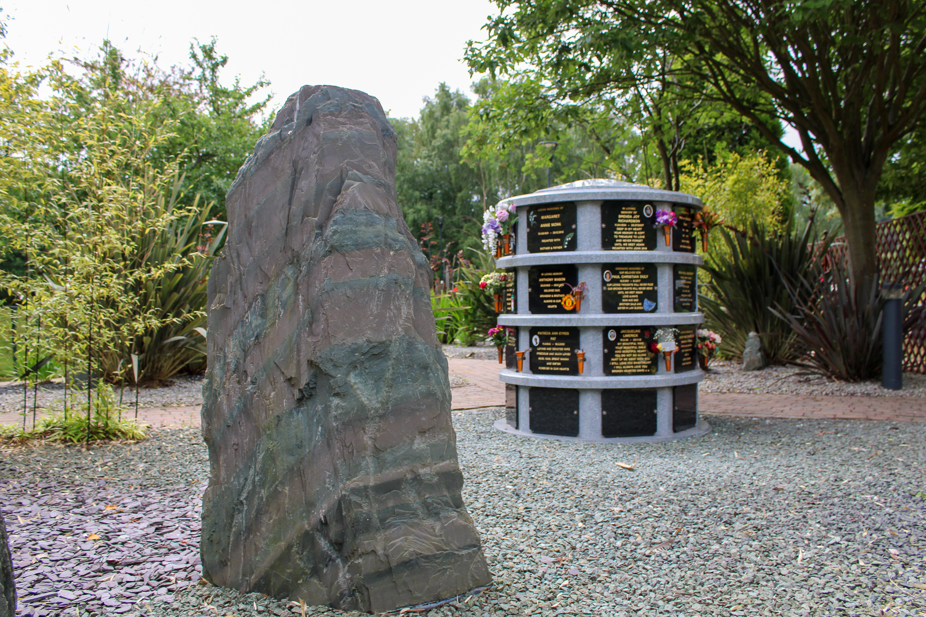

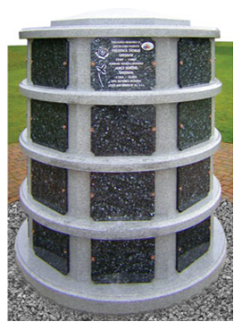

**There are options for the lease of the Columbarium**

5 Year Lease

10 Year Lease

25 Year Lease

**See attached price list for prices**

**Plaques**

The Lease options include a black granite plaque with the first 80 gilded letters. Additional letters are available at a cost of £2.50 a letter if ordered with the original order.

Design options are available at the Bereavement Services Office.

A photo plaque 7” x 5” can be added for a cost of £135.00 (if ordered with the original order)

* A simple design can be added for a cost of £ P.O.A (if ordered with the original order)
* A bespoke design can be added for an individual cost.

**Columbarium Plaque Example**

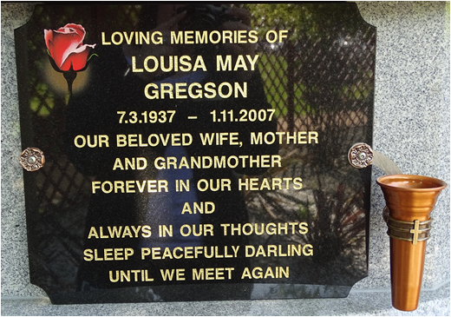

A memorial application can be refused if, in the opinion of the manager, the inscription would be unsuitable for the Reflection Garden.

**Flowers containers**

A metal flower container for natural flowers can be incorporated into the memorial at an extra cost of £53.00.

No additional vases, flower containers, memorials, articles or things are to be placed upon these memorial gardens or within the Reflection Garden. We may remove any withered or dead flowers.

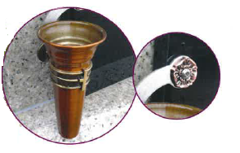

**Ashes containers**

Only metal urns, wooden caskets and polytainers will be permitted.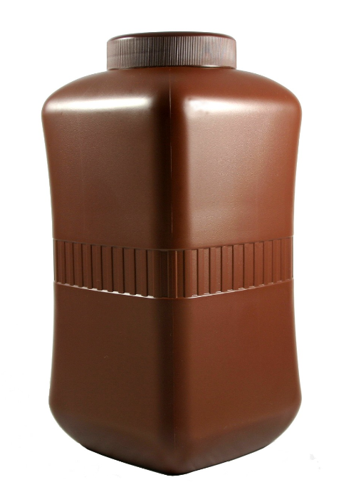

All are available from the Bereavement Services Office.

**Memorial Order Form**

**Columbarium Large Plaque Design - 5 / 10 / 25 year Lease**

Do you require a Posy Vase: **YES / NO**

|  |  |  |  |  |  |  |  |  |  |  |  |  |  |  |  |  |  |  |  |  |  |  |  |  |  |
| --- | --- | --- | --- | --- | --- | --- | --- | --- | --- | --- | --- | --- | --- | --- | --- | --- | --- | --- | --- | --- | --- | --- | --- | --- | --- |
|  | **1** | **2** | **3** | **4** | **5** | **6** | **7** | **8** | **9** | **10** | **11** | **12** | **13** | **14** | **15** | **16** | **17** | **18** | **19** | **20** | **21** | **22** | **23** | **24** | **25** |
| **Line 1** |  |  |  |  |  |  |  |  |  |  |  |  |  |  |  |  |  |  |  |  |  |  |  |  |  |
| **Line 2** |  |  |  |  |  |  |  |  |  |  |  |  |  |  |  |  |  |  |  |  |  |  |  |  |  |
| **Line 3** |  |  |  |  |  |  |  |  |  |  |  |  |  |  |  |  |  |  |  |  |  |  |  |  |  |
| **Line 4** |  |  |  |  |  |  |  |  |  |  |  |  |  |  |  |  |  |  |  |  |  |  |  |  |  |
| **Line 5** |  |  |  |  |  |  |  |  |  |  |  |  |  |  |  |  |  |  |  |  |  |  |  |  |  |
| **Line 6** |  |  |  |  |  |  |  |  |  |  |  |  |  |  |  |  |  |  |  |  |  |  |  |  |  |
| **Line 7** |  |  |  |  |  |  |  |  |  |  |  |  |  |  |  |  |  |  |  |  |  |  |  |  |  |
| **Line 8** |  |  |  |  |  |  |  |  |  |  |  |  |  |  |  |  |  |  |  |  |  |  |  |  |  |
| **Line 9** |  |  |  |  |  |  |  |  |  |  |  |  |  |  |  |  |  |  |  |  |  |  |  |  |  |
| **Line 10** |  |  |  |  |  |  |  |  |  |  |  |  |  |  |  |  |  |  |  |  |  |  |  |  |  |
| **Line 11** |  |  |  |  |  |  |  |  |  |  |  |  |  |  |  |  |  |  |  |  |  |  |  |  |  |

Design: ……………………………………………………………………………………………………………………………………………………………………

**Deceased details:**

Name: ………………………………………………………………………… Date of Death: …………………………. Cremation Ref: ……………………...

Name: ………………………………………………………………………… Date of Death: ………………………… Cremation Ref: ……………………...

|  |  |  |  |
| --- | --- | --- | --- |
| **Office Use Only:** |  |  |  |
| **Date** | **Agreement Number** | **Receipt Number** | **Plaque Location** |
|  |  |  |  |

**Memorial Order Form**

**Columbarium Large Plaque No Design - 5 / 10 / 25 year Lease**

Do you require a Posy Vase: **YES / NO**

|  |  |  |  |  |  |  |  |  |  |  |  |  |  |  |  |  |  |  |  |  |  |  |  |  |  |
| --- | --- | --- | --- | --- | --- | --- | --- | --- | --- | --- | --- | --- | --- | --- | --- | --- | --- | --- | --- | --- | --- | --- | --- | --- | --- |
|  | **1** | **2** | **3** | **4** | **5** | **6** | **7** | **8** | **9** | **10** | **11** | **12** | **13** | **14** | **15** | **16** | **17** | **18** | **19** | **20** | **21** | **22** | **23** | **24** | **25** |
| **Line 1** |  |  |  |  |  |  |  |  |  |  |  |  |  |  |  |  |  |  |  |  |  |  |  |  |  |
| **Line 2** |  |  |  |  |  |  |  |  |  |  |  |  |  |  |  |  |  |  |  |  |  |  |  |  |  |
| **Line 3** |  |  |  |  |  |  |  |  |  |  |  |  |  |  |  |  |  |  |  |  |  |  |  |  |  |
| **Line 4** |  |  |  |  |  |  |  |  |  |  |  |  |  |  |  |  |  |  |  |  |  |  |  |  |  |
| **Line 5** |  |  |  |  |  |  |  |  |  |  |  |  |  |  |  |  |  |  |  |  |  |  |  |  |  |
| **Line 6** |  |  |  |  |  |  |  |  |  |  |  |  |  |  |  |  |  |  |  |  |  |  |  |  |  |
| **Line 7** |  |  |  |  |  |  |  |  |  |  |  |  |  |  |  |  |  |  |  |  |  |  |  |  |  |
| **Line 8** |  |  |  |  |  |  |  |  |  |  |  |  |  |  |  |  |  |  |  |  |  |  |  |  |  |
| **Line 9** |  |  |  |  |  |  |  |  |  |  |  |  |  |  |  |  |  |  |  |  |  |  |  |  |  |
| **Line 10** |  |  |  |  |  |  |  |  |  |  |  |  |  |  |  |  |  |  |  |  |  |  |  |  |  |
| **Line 11** |  |  |  |  |  |  |  |  |  |  |  |  |  |  |  |  |  |  |  |  |  |  |  |  |  |

Design: ……………………………………………………………………………………………………………………………………………………………………

**Deceased details:**

Name: ………………………………………………………………………… Date of Death: …………………………. Cremation Ref: ……………………...

Name: ………………………………………………………………………… Date of Death: ………………………… Cremation Ref: ……………………...

|  |  |  |  |
| --- | --- | --- | --- |
| **Office Use Only:** |  |  |  |
| **Date** | **Agreement Number** | **Receipt Number** | **Plaque Location** |
|  |  |  |  |



**Plaque Inscription Guidelines**

**Columbarium Large Plaque Design**

In order to ensure that an inscription will fit onto the granite tablet, please note the following information:

* The names are in large typeface and take up more room on the tablet therefore only 18 letters are permitted on name lines only. (See dotted Line).
* If a large design is required please do not use the shaded boxes for the inscription.
* If you require a further inscription on the tablet please ensure that enough lines are left for the inscription.
* We will centre the inscription on the tablet, the guide box is only to aid your choice of inscription.
* Don’t forget to include spaces in your inscription. A space counts as a letter or number.
* The inscription must be clearly written in block capitals.
* We are unable to accept responsibility for any incorrect inscription due to illegible or ambiguous writing.

**Columbarium Large Plaque No Design**

In order to ensure that an inscription will fit onto the granite tablet, please note the following information:

* The names are in large typeface and take up more room on the tablet therefore only 18 letters are permitted on name lines only. (See dotted Line).
* If you require a further inscription on the tablet please ensure that enough lines are left for the inscription.
* We will centre the inscription on the tablet, the guide box is only to aid your choice of inscription.
* Don’t forget to include spaces in your inscription. A space counts as a letter or number.
* The inscription must be clearly written in block capitals.
* We are unable to accept responsibility for any incorrect inscription due to illegible or ambiguous writing.

 **Bramcote Crematorium-**



Coventry Lane, Bramcote, Nottingham NG9 3GJ

Telephone: 0115 917 3849 Fax: 0115 943 0067

Email: bramcotecrem@broxtowe.gov.uk

www.bramcotebereavement.org

**Grounds Rules and Regulations**

These Rules and Regulations are applicable to all visitors to the Crematorium and grounds.

The Crematorium is managed by the Bramcote Bereavement Services Joint Committee **(BBSJC**)

Smoking is not permitted in the Crematorium building and we would politely ask that visitors refrain from smoking in the remembrance grounds if possible. If you must smoke, please dispose of all waste matter and stubs responsibly in the bins provided.

All persons shall conduct themselves with due reverence and respect whilst in the Crematorium and grounds, respecting the need for sensitivity, quiet and privacy in all remembrance areas. The disposal of Cremated Remains within the grounds can only be conducted by a prior appointment with the office. Unauthorised scatterings/disposals will be removed.

Children under 16 years of age are not allowed within the Crematorium Grounds except under the supervision of a responsible adult. Dogs and animals are not permitted in the Crematorium grounds, except for registered assistance dogs. Dogs/pets may only attend a funeral with prior notice to the Crematorium office.

Cut flowers, without wrapper or binding may be left in the Woodland Walk, the Reflection Garden and Interment areas. Flowers in containers, frames, pots or tubs should only be left in the area provided in the Reflection garden. Any items inappropriately placed elsewhere will be relocated to the Reflection Garden by our grounds team.

The **BBSJC** accepts no responsibility for plants or flowers left in the grounds other than for their clearance if they have deteriorated or been damaged by wildlife.

Artificial flowers are only permitted on Woodland Walk private graves or with a wall plaque memorial and must be contained in the flower container provided as part of the memorial. Artificial flowers are not permitted anywhere else within the Crematorium grounds; except for during the Christmas period (concluding on January 6th). Those that are found after this date will be removed and disposed of.

Receptacle’s for flowers placed or formed in the ground for flowers are not permitted. Such items pose a hazard to safety and will be removed or filled immediately.

The hanging of personal items, decorations, balloons or flowers from memorials, trees or bushes is not permitted and such items will be removed and disposed of immediately.

Wind chimes, wooden crosses or other temporary memorials are not permitted and will be removed and disposed of immediately.

The Crematorium has a structured grounds maintenance programme. The private planting of trees, plants, shrubs and bulbs is prohibited. Any such planted items will be removed and replanted within the Borough of Broxtowe.

The **BBSJC** reserves the right to remove or relocate any items which were previously donated or are without a lease agreement. The alteration or adjustment of a memorial can only be done after prior notice and consent of the Crematorium office. All work approved will be undertaken by the Crematorium staff only

April 2023



**BRAMCOTE BEREAVEMENT SERVICES JOINT COMMITTEE**

Coventry Lane, Bramcote, Nottingham, NG9 3GJ

Telephone 0115 9173849 Fax 0115 943 0067

**RENEWABLE LEASE AGREEMENT FOR COLUMBARIUM NICHE**

WE, the Bramcote Bereavement Services Joint Committee, (the grantor) in consideration of the sum of: -

…………………………………………………………………………………………….(£…………………….)

Paid to us by: ………………………………………………………………………………………(the grantee)

(Full name of applicant in BLOCK CAPITALS)

Of: …………………………………………………………………………………………………………………

……………………………………………………………………………………………………………………..

(Address in BLOCK CAPITALS)

Postcode: …………………………………………………………………………………………………………..

Telephone Contacts: Home: ……………………………... Mobile: ………………………………….............

Email Address: …………………………………………………………………………………………………….

1. DO HEREBY GRANT UNTO the said grantee, the right to place cremated remains within Columbarium Niche numbered ..................of the Columbarium 1 Memorial at the Bramcote Crematorium for a period of time not exceeding 5/10/25**\*** years from the date hereof.
2. This Lease is subject also to the Grounds Rules and Regulations applicable at the time of granting, but which may subsequently be altered and amended (a copy is present Rules and Regulations is enclosed)
3. This right may be renewed on expiry of the 5/10/25**\*** years by payment of the appropriate fee applicable at that time.
4. The Niche shall have provision for up to 3 (Three) sets of cremated remains, subject to suitable containment and the granite plaque provided shall be inscribed only by the grantor and shall remain the property of the grantor, who shall care for the plaque during the Lease period.
5. There is no restriction on the number or size of inscriptions on the plaque, but the grantor reserves the right to refuse any inscription, should the wording and content be deemed inappropriate or offensive. The decision of the Bereavement Services Manager on this matter will be final.
6. Up to 2 flower containers, supplied only by the grantor, may be added to the plaque, but are not included within the initial lease cost. These may be added by the grantee at any time, on payment of the appropriate fee applicable at the time of purchase.
7. Flowers placed in the containers supplied must be contained within the width and height of the plaque itself and not overhang or impede the viewing of other plaques. Any so placed will be re-arranged to fit or relocated to containers in the Reflection garden by the Crematorium staff.
8. Any natural flowers placed within the vases will be removed by the crematorium staff, once they are considered to have died or their condition has sufficiently deteriorated that they are considered to be detracting from the respectful appearance of the Columbarium.
9. Any artificial flowers placed in the containers will be removed, should their condition fade or deteriorate to the extent that they are considered to be detracting from the respectful appearance of the Columbarium.
10. No personal items, memorabilia, trinkets, photographs (other than those provided with the plaque) letters, notes or cards may affixed to the plaque or be placed on or near the Columbarium – any such item will be immediately removed and discarded without further notice. The grantee will be advised immediately of any such issues as repeated or sustained occurrences may result in the Lease being terminated without refund.
11. If, at the end of the lease period, the right to the vault is not renewed, then, in the absence of any other instructions, after a period of 4 weeks from the renewal date, the cremated remains will be removed from the vault and will be scattered within the Crematorium grounds. This will only be done after reasonable efforts have been made to contact the grantee**\*\***
12. The memorial plaque will be retained for 4 weeks after the lease period expires and may be collected by the grantee, if they so choose. If not collected within that period the plaque will be sensitively recycled.
13. PAY MONTHLY: Any additional extras are chargeable at deposit stage. Payments are taken on a set day each month. The first payment is taken 1 month after your initial deposit. Our dedicated memorial team member will call you when payments fall due. Failure to maintain payments could result in your memorial being removed and made available for you to collect. (See point 19.)
14. The above right may be rescinded at any time during the lease period on the written instructions of the grantee, who shall then arrange collection of the cremated remains from the Crematorium within a 4 week-period. If the remains are not collected within that period, they will be removed and scattered within the Crematorium Grounds without further notice. The plaque, which remains the property of the Bereavement Services Joint Committee, will then be sensitively recycled.
15. It is the responsibility of the grantee to advise any change of address and ensure that the rights are renewed. Although the grantor will endeavour to contact the grantee before expiry of the right, no responsibility can be accepted for action taken in the absence of renewal of the right, or alternative instructions from the grantee.
16. All inscription work on the plaque shall be ordered through the grantor who will arrange for the works to be completed.
17. The Lease relates only to the right to place cremated remains within the Niche. The Niche, plaque and associated areas remain the property of the Bramcote Crematorium Joint Committee and are subject also to the Rules and Regulations applicable at the time of purchase and which may be altered or amended thereafter. The grantee is required to uphold and maintain the Rules and Regulations and ensure that other relatives or visitors to their Niche similarly uphold these.
18. In the event of the death of the grantee, his/her remains may be placed within the Niche on instruction of the Applicant for their cremation, but no additional inscription may be added without the Niche rights being legally transferred beforehand.
19. Any breach of the Rules and Regulations will be noted and immediately addressed with the grantee. Should there be a repeated or sustained breach of the Rules and Regulations, the grantor reserves the right to immediately terminate the Lease agreement, without further noticed or refund. In such case, the grantee will be advised of the termination in writing, after which the grantee must arrange to collect the remains from the Crematorium within a 4-week period. If the remains are not collected within the 4-week period, the remains will be removed and scattered within the Crematorium grounds without further notice.

**\***Delete as applicable.

**\*\*** ‘Reasonable attempts’ are defined as being: -

• Telephoning any numbers held on file

• Emailing via address held on file

• Writing to the applicant at the contact address held on file and hand-delivering a copy of the

notice to the applicant’s home address, if the address is not notice to the applicant’s home

address, if the address is not exceeding a total journey distance of 15 miles.

I, ……………………………………………………………………………………………………..(the grantee), confirm that I have read and understood this Lease agreement, its Terms and Conditions and have received also a copy also of the current Grounds Rules and Regulations.

I accept all the information, policies and procedures outlined within this lease agreement and the Grounds Rules and Regulations and agree to be bound by them.

I confirm this by signing below.

Signed: ............................................................................................................. for grantee

Date: ................................................................................................................

Signed: ............................................................................................................. for grantor

Date: .............................................................................................................

N.B. You will be given a copy of this agreement for your records. Please keep it in a safe place and advise your next of kin/executors of its existence.

To enable us to advise you of any renewal or essential works required it is important that you keep the Bereavement Services Office informed of any change of address.

The Lease can be transferred to another person at any time during the Lease period by written notice being given by the grantee to the Office – the administrative fee applicable at that time will apply.

In the event of the death of the grantee please contact the Bereavement Services Office as the rights to a Niche do not automatically transfer to relatives or executors and may have to be formally and legally transferred. This could incur administrative costs and delay any remains being placed within the Niche or additional inscriptions being added to the plaque.

**Columbarium Price List 01/04/2023 – 31/03/2024**

The price structure below depends on the Level you would like the plaque on.  
Level A is on the top row of the Columbarium & Level D is on the bottom row.  
You can now spread the cost of our Columbarium Memorial over 12 months. With deposits starting from £132 and Monthly payments starting from £78.  
For further information contact our dedicated Memorial Team.

**Level A (Top)**

|  |  |
| --- | --- |
| Plaque & Cremated Remains – 5 year Lease | **£948.00** |
| Plaque & Cremated Remains – 10 year Lease | **£1,422.00** |
| Plaque & Cremated Remains – 25 year Lease | **£2,255.00** |

**Level B**

|  |  |
| --- | --- |
| Plaque & Cremated Remains – 5 year Lease | **£946.00** |
| Plaque & Cremated Remains – 10 year Lease | **£1,419.00** |
| Plaque & Cremated Remains – 25 year Lease | **£2,255.00** |

**Level C**

|  |  |
| --- | --- |
| Plaque & Cremated Remains – 5 year Lease | **£857.00** |
| Plaque & Cremated Remains – 10 year Lease | **£1,274.00** |
| Plaque & Cremated Remains – 25 year Lease | **£2,030.00** |

**Level D (Bottom)**

|  |  |
| --- | --- |
| Plaque & Cremated Remains – 5 year Lease | **£756.00** |
| Plaque & Cremated Remains – 10 year Lease | **£1,128.00** |
| Plaque & Cremated Remains – 25 year Lease | **£1,804.00** |

**Renewals**

|  |  |
| --- | --- |
| Columbarium Plaque – Renewable 5 year Lease | **£POA** |
| Columbarium Plaque – Renewable 10 year Lease | **£POA** |

**Extras**

|  |  |
| --- | --- |
| Extra Lettering over 80 Letters | **£2.50 a Letter** |
| Photo plaque 7cm x 5cm | **£135.00** |
| Metal Posy Vase | **£53.00** |
| Designs | **Price On Request** |